Advanced Data Analysis and Visualization
in Logistics Operations
Week 3 Task Report
Exploratory Data Analysis, Visualization & Operational Insights
Prepared using Python (pandas, NumPy, matplotlib, seaborn)
Dataset: Simulated Logistics Shipments, 2025 (n = 2,000 records)

Table of Contents
1. Executive Summary
2. Methodology
2.1 Data Simulation
2.2 Tools and Libraries
3. Exploratory Data Analysis
3.1 Central Tendency and Spread
3.2 On-Time Delivery Performance
3.3 Correlation Analysis
4. Visualizations
4.1 Distribution of Delivery Times
4.2 Delivery Time by Transport Mode
4.3 Transport Cost vs. Distance
4.4 Correlation Matrix of Key Logistics Metrics
4.5 Monthly Shipment Volume and On-Time Delivery Rate
4.6 On-Time Delivery Rate by Region and Transport Mode
4.7 Average Cost per Kilogram by Transport Mode
5. Analytical Insights and Recommendations
6. Conclusion
Appendix A. Full Python Script References

1. Executive Summary
This report applies exploratory data analysis (EDA) and visualization techniques to a simulated logistics dataset of 2,000 shipments made across five regions and four transport modes (Road, Rail, Air, Sea) over a 12-month period. The objective is to identify patterns in delivery performance, cost structure, and customer satisfaction that can inform operational decision-making.
Key findings include: (1) overall on-time delivery performance stands at 71.2%, with Sea freight lagging significantly behind other modes; (2) transport cost is very strongly correlated with distance (r = 0.90), confirming distance as the primary cost driver, while Air freight carries a per-kilogram cost roughly 20-45x higher than surface modes; (3) customer satisfaction is most strongly (and negatively) associated with delivery time relative to the promised SLA window (r = -0.57), more so than with cost; and (4) on-time performance varies meaningfully by region-mode combination, pointing to specific operational bottlenecks rather than a uniform, company-wide problem.
Recommendations focus on tightening Sea-freight scheduling buffers, reviewing Air-freight usage for cost-sensitive shipments, and prioritizing on-time performance improvements in the lowest-performing region-mode pairs identified in Section 4.6.

2. Methodology

2.1 Data Simulation
Since a real proprietary logistics dataset was not available for this exercise, a realistic synthetic dataset was generated with NumPy and pandas to mirror the structure of an actual shipment-level logistics dataset. Each of the 2,000 records represents a single shipment and includes the fields summarized in Table 1.
Field | Description
shipment_id | Unique shipment identifier
ship_date / month | Date the shipment was dispatched (2025)
region | Destination region: North, South, East, West, Central
transport_mode | Road, Rail, Air, or Sea
distance_km | Shipment distance in kilometers
shipment_volume_kg | Shipment weight/volume in kilograms
delivery_time_hours | Total time from dispatch to delivery
sla_hours / on_time | Promised delivery window and whether it was met
transport_cost_usd / cost_per_kg | Total and unit transport cost
customer_satisfaction | Simulated post-delivery satisfaction score (1-5)

Delivery time was modeled as a function of distance, mode-specific average speed, handling time, and a stochastic operational-delay component (larger and more variable for Sea and Rail than for Air and Road, reflecting real-world port/rail congestion effects). Transport cost combined a distance-based rate specific to each mode with a volume surcharge and random fuel-price noise. Service-level agreement (SLA) windows were set per mode (Road 24h, Rail 30h, Air 14h, Sea 50h) and calibrated against the simulated delivery-time distributions so that on-time performance would vary meaningfully — an unrealistically perfect 100% on-time rate would provide no analytical signal.

2.2 Tools and Libraries
The analysis was conducted entirely in Python, using the following libraries:
- pandas / NumPy — data simulation, cleaning, aggregation, and correlation analysis
- matplotlib / seaborn — statistical visualization (distributions, boxplots, scatter plots, heatmaps)
- A three-stage script pipeline: (1) data simulation, (2) EDA, (3) visualization generation
# Excerpt from 01_simulate_data.py — core shipment generation loop
base_hours = distance_km / profile['speed_kmph']
handling_hours = np.random.gamma(shape=2.0, scale=3.0)
delay_hours = np.abs(np.random.normal(loc=profile['delay_std']*0.6,
scale=profile['delay_std']))
delivery_time_hours = base_hours + handling_hours + delay_hours
sla_hours = {'Road': 24, 'Rail': 30, 'Air': 14, 'Sea': 50}[mode]
on_time = delivery_time_hours <= sla_hours

3. Exploratory Data Analysis

3.1 Central Tendency and Spread
Table 2 summarizes the core numeric variables. All cost and volume variables are right-skewed, which is typical of logistics data where most shipments are small/medium but a minority of large or long-haul shipments pull the mean above the median.
Metric | Mean | Median | Std Dev | Skew
Distance (km) | 704.3 | 512.4 | 639.9 | 3.17
Volume (kg) | 630.3 | 404.9 | 762.8 | 6.98
Delivery time (h) | 24.8 | 22.4 | 14.8 | 1.78
Transport cost (USD) | 1,215.9 | 565.7 | 2,839.2 | 3.78
Cost per kg (USD) | 4.46 | 2.10 | 15.11 | 7.94
Customer satisfaction (1-5) | 3.95 | 4.15 | 0.74 | -0.58

3.2 On-Time Delivery Performance
Overall, 71.2% of shipments were delivered within their SLA window. Performance by mode:
Transport Mode | On-Time Rate | Avg. Cost/kg (USD)
Air | 73.7% | $32.95
Road | 74.6% | $1.49
Rail | 69.3% | $1.45
Sea | 60.5% | $0.71

Sea freight is both the cheapest mode per kilogram and the least reliable in meeting its own (relatively generous) SLA window, making it the primary lever for on-time-performance improvement.

3.3 Correlation Analysis
A Pearson correlation matrix (visualized in Figure 4) was computed across the numeric fields. The strongest relationships are:
- distance_km vs. transport_cost_usd: r = 0.90 — distance is the dominant driver of total shipment cost.
- distance_km vs. cost_per_kg: r = 0.63 — longer hauls also carry a higher per-unit cost, consistent with greater reliance on Air/Sea for long distances.
- delivery_time_hours vs. customer_satisfaction: r = -0.57 — the strongest predictor of satisfaction in the dataset, exceeding the influence of cost.
- shipment_volume_kg shows weak correlation with all other variables, suggesting volume is largely independent of routing and timing decisions in this dataset.

4. Visualizations
Seven visualizations were produced to examine distribution shape, categorical comparisons, bivariate relationships, multivariate correlation structure, time trends, and cross-tabulated performance. Each chart type was chosen to match the analytical question it answers, per Table 3.
# | Chart Type | Question Answered
1 | Histogram + KDE | How are delivery times distributed?
2 | Boxplot | How does delivery time vary by transport mode?
3 | Scatter plot | How does cost relate to distance, by mode?
4 | Heatmap | Which metrics move together across the whole dataset?
5 | Dual-axis bar/line | How do volume and reliability trend over the year?
6 | Grouped bar chart | Where do on-time bottlenecks concentrate (region x mode)?
7 | Bar chart (log scale) | How does unit cost compare across modes with a wide value range?

4.1 Distribution of Delivery Times
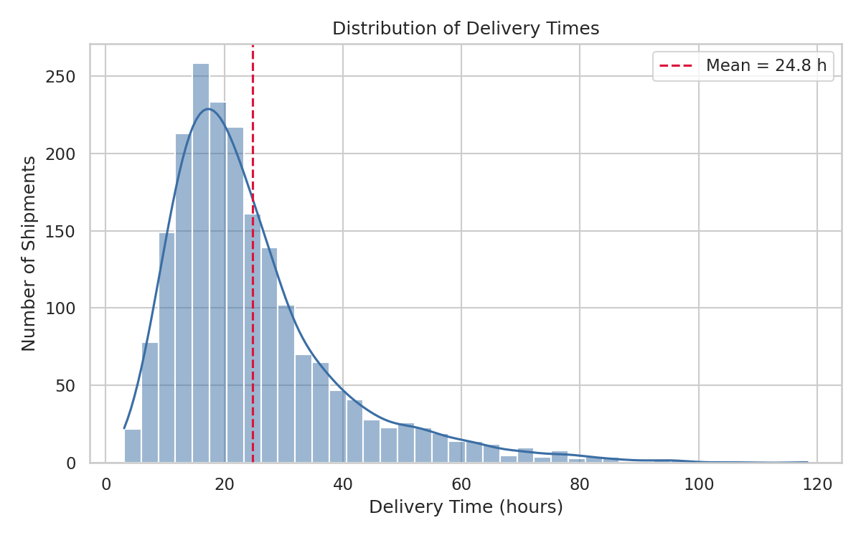
Figure 1. Distribution of Delivery Times
Why this chart: A histogram with a kernel density overlay is the standard tool for examining the shape, center, and spread of a continuous variable, and for spotting skew or multimodality that summary statistics alone can hide.
Insight: Delivery times cluster between roughly 12 and 35 hours with a long right tail driven mainly by Sea shipments. The distribution is right-skewed (skew = 1.78), meaning a small number of very slow shipments pull the average above the typical (median) delivery experience — a pattern operations teams should track using the median and 90th-percentile delivery time, not the mean alone.

4.2 Delivery Time by Transport Mode
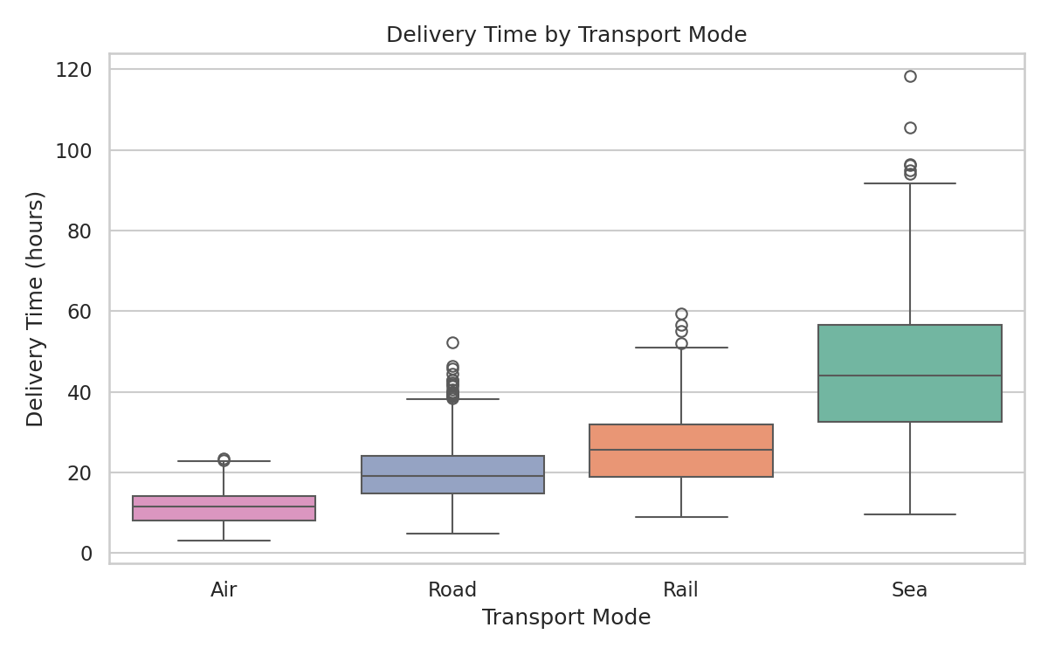
Figure 2. Delivery Time by Transport Mode
Why this chart: A boxplot is well suited to comparing the distribution (median, interquartile range, and outliers) of a continuous variable across several categories side by side.
Insight: Air freight is fastest and most consistent (narrow interquartile range), while Sea freight is both the slowest and the most variable, with a wide spread and numerous high outliers. This variability — not just the average transit time — is what drives Sea's poor SLA compliance, since a wide spread makes any fixed SLA window harder to meet consistently.

4.3 Transport Cost vs. Distance
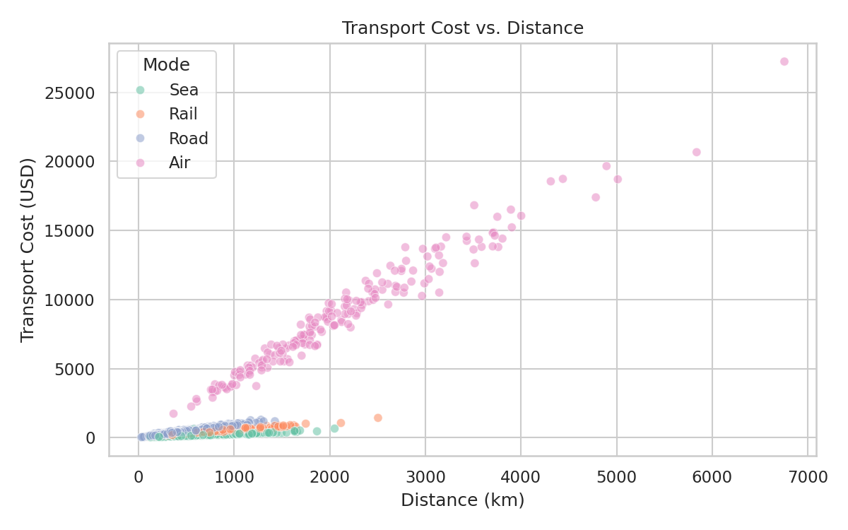
Figure 3. Transport Cost vs. Distance
Why this chart: A scatter plot, colored by transport mode, reveals the bivariate relationship between two continuous variables while allowing a third categorical dimension (mode) to be inspected simultaneously.
Insight: Cost rises approximately linearly with distance within each mode, confirming distance-based pricing logic. Air freight (visible as the steepest, highest cluster) commands a substantially higher cost per kilometer than Road, Rail, or Sea, making it economically justified mainly for time-critical or high-value shipments rather than routine long-haul volume.

4.4 Correlation Matrix of Key Logistics Metrics
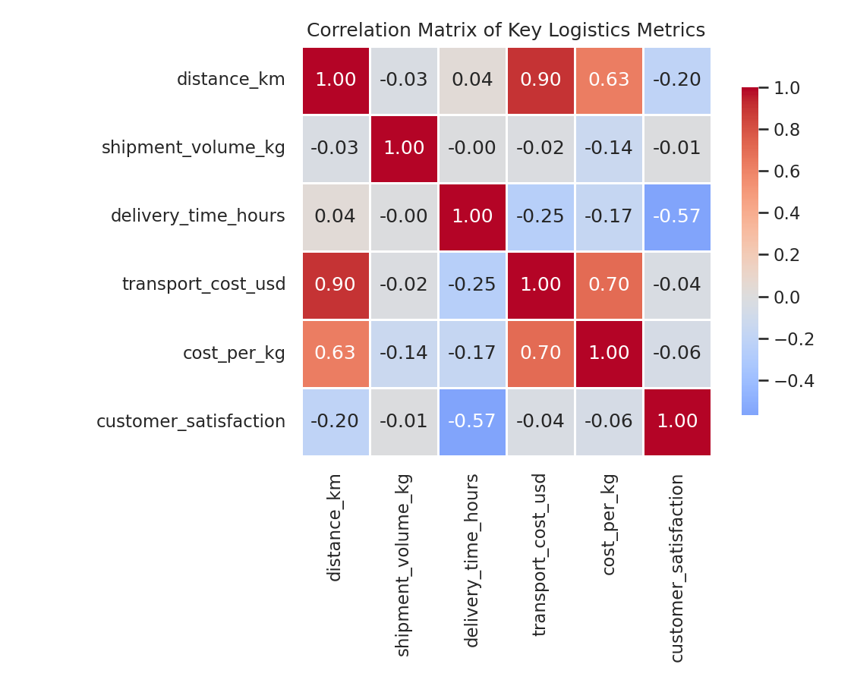
Figure 4. Correlation Matrix of Key Logistics Metrics
Why this chart: A heatmap condenses a full correlation matrix into a single, quickly scannable view, making it efficient for spotting the strongest linear relationships across many variable pairs at once.
Insight: Beyond the strong distance-cost relationship, the heatmap highlights that customer satisfaction correlates far more strongly with delivery time (-0.57) than with cost (-0.04), a non-obvious finding with direct implications for where investment should be prioritized: speed and reliability improvements are likely to move satisfaction more than price reductions.

4.5 Monthly Shipment Volume and On-Time Delivery Rate
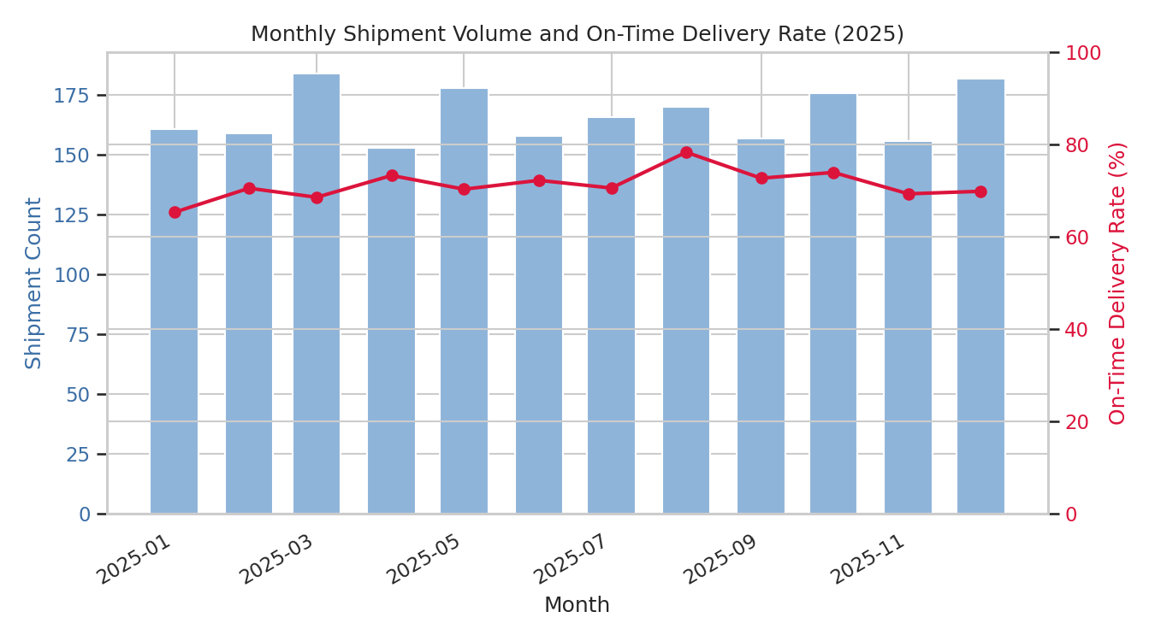
Figure 5. Monthly Shipment Volume and On-Time Delivery Rate
Why this chart: A dual-axis combination chart overlays a volume trend (bars) with a rate trend (line) on a shared time axis, making it possible to see whether reliability holds up as demand fluctuates.
Insight: Shipment volume is fairly stable across the year (roughly 150-185 shipments/month) without a strong seasonal spike. On-time performance fluctuates between about 65% and 78% without a clear volume-driven pattern, suggesting reliability issues stem more from structural mode/region factors (see Figure 6) than from seasonal capacity strain.

4.6 On-Time Delivery Rate by Region and Transport Mode
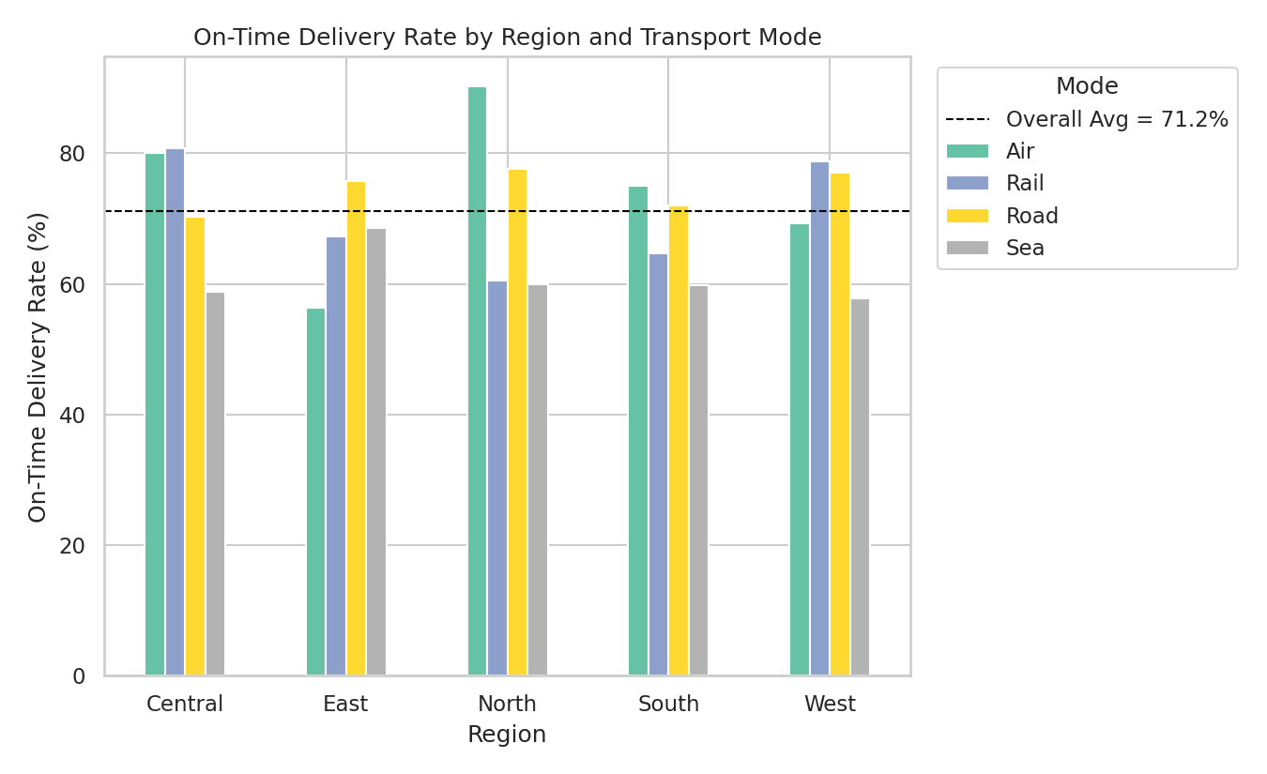
Figure 6. On-Time Delivery Rate by Region and Transport Mode
Why this chart: A grouped bar chart cross-tabulates two categorical dimensions (region and mode) against a performance metric, which is the most direct way to localize where a company-wide average is masking specific weak spots.
Insight: On-time performance is not uniform within a mode across regions — Sea freight in particular shows the widest regional spread, indicating that port congestion, customs processing, or last-mile handling in specific regions (rather than sea transit itself) may be the true bottleneck. This is the clearest actionable finding in the report: targeted fixes in the weakest region-mode pairs will move the company average more efficiently than a blanket policy change.

4.7 Average Cost per Kilogram by Transport Mode
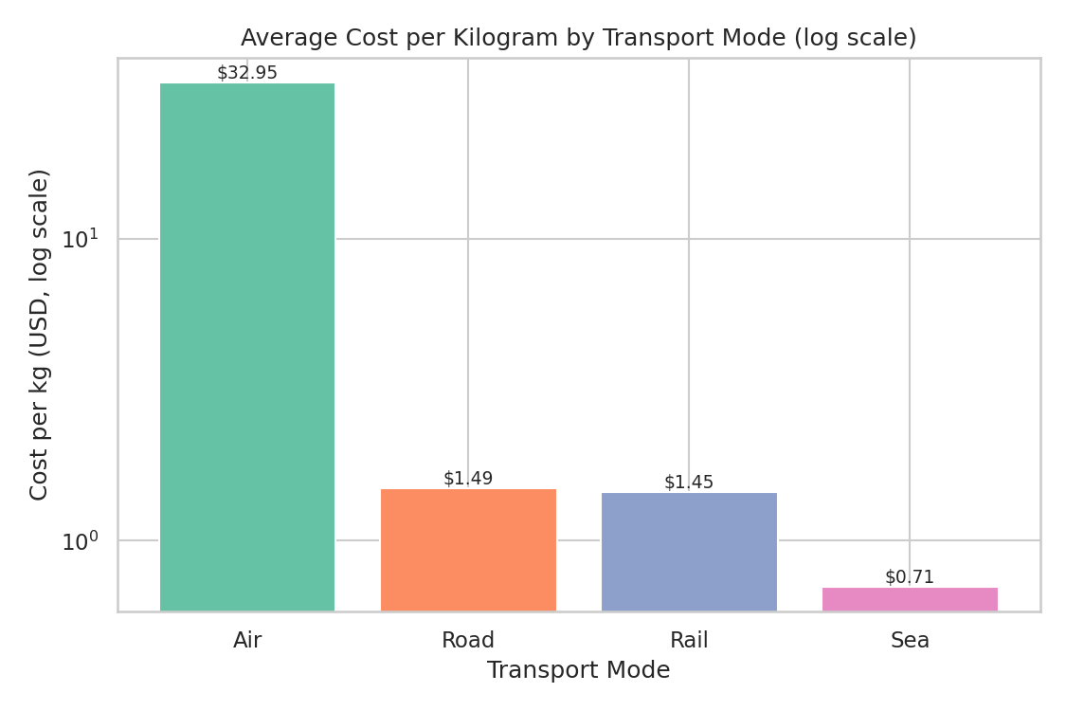
Figure 7. Average Cost per Kilogram by Transport Mode
Why this chart: Because Air freight's per-kg cost is an order of magnitude higher than surface modes, a log-scale bar chart is necessary so that Rail, Road, and Sea remain visually comparable rather than being flattened near zero next to Air.
Insight: Air costs roughly $32.95/kg versus $0.71-$1.49/kg for Sea, Rail, and Road — a 20-45x premium. This quantifies the cost of prioritizing speed and frames the Air-vs-Sea/Road tradeoff explicitly for shipment planning: Air should be reserved for shipments where the value of speed clearly exceeds this premium.

Appendix A. Full Python Script References
The complete Python scripts used for this analysis (01_simulate_data.py, 02_eda.py, and 03_visualizations.py) are provided alongside this report. Key excerpts from the EDA and visualization stages are reproduced below.
# Excerpt from 02_eda.py
numeric_cols = ['distance_km', 'shipment_volume_kg', 'delivery_time_hours',
'transport_cost_usd', 'cost_per_kg', 'customer_satisfaction']
desc = df[numeric_cols].describe().T
desc['skew'] = df[numeric_cols].skew()
corr = df[numeric_cols].corr()
# Excerpt from 03_visualizations.py — correlation heatmap
sns.heatmap(corr, annot=True, fmt='.2f', cmap='coolwarm', center=0,
square=True, linewidths=0.5, cbar_kws={'shrink': 0.8})
plt.title('Correlation Matrix of Key Logistics Metrics')
# Excerpt from 03_visualizations.py — region x mode on-time bar chart
pivot = df.groupby(['region', 'transport_mode'])['on_time'].mean().unstack() * 100
pivot.plot(kind='bar', ax=plt.gca(), colormap='Set2')
plt.axhline(df['on_time'].mean() * 100, color='black', linestyle='--',
label=f'Overall Avg = {df["on_time"].mean()*100:.1f}%')

6. Conclusion
This analysis demonstrates how a structured EDA and visualization workflow in Python can turn raw shipment records into concrete, prioritized operational recommendations. The combination of distributional, categorical, correlational, and time-based views provided a complete picture: distance drives cost, delivery time drives satisfaction, and on-time performance gaps are concentrated in specific mode-region combinations rather than spread evenly across the network. Applying this same pipeline to real shipment data would let the logistics team validate these patterns and monitor them on an ongoing basis.

